Day 3 Assignment 3

Agile Software Process and its Principles :-

Agile Software Process:-

In Agile Any Agile Software Process is characterized in a manner that addresses a variety of key assumptions concerning the bulk of software projects:

* It is troublesome to predict before that software needs will persist and can be amended. it’s equally troublesome to predict however client priorities can be amended because of the project payoff.
* For many sorts of software, style and construction are interleaved. That is, each activity ought to be performed in order that style models are verified as they’re created. it’s troublesome to predict what proportion of design is critical before construction is employed to prove the look.
* Analysis, design, construction, and testing aren’t as inevitable (from a design purpose of view) as we’d like.

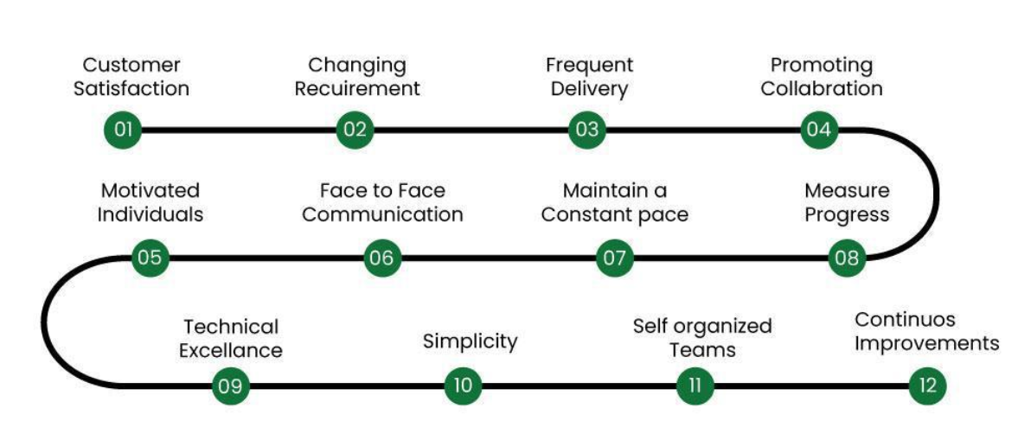

Agile Principals :-

1. Our highest priority is to satisfy the client through early and continuous delivery of valuable computer software.
2. Welcome dynamic necessities, even late in development. Agile processes harness modification for the customer’s competitive advantage.
3. Deliver operating computer software often, from a pair of weeks to a couple of months, with a preference to the shorter timescale.
4. Business individuals and developers should work along daily throughout the project.
5. The build comes around actuated people. offer them the setting and support they have, and trust them to urge the task done.
6. the foremost economical and effective methodology of conveyancing info to and among a development team is face-to-face speech.
7. Working with computer software is the primary life of progress.
8. Agile processes promote property development. The sponsors, developers, and users will be able to maintain a relentless pace indefinitely.
9. Continuous attention to technical excellence and smart style enhances nimbleness.

1. Simplicity—the art of maximizing the number of work not done—is essential.
2. the most effective architectures, necessities, and styles emerge from self–organizing groups.
3. At regular intervals, the team reflects on a way to become simpler, then tunes and adjusts its behavior consequently.